Current Functionality
When Gross Annual Salary or Benefit Salary are used in the Additional Eligibility Criteria
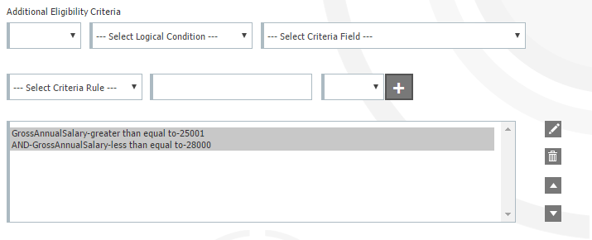
The system does not consider the update elections for salary changes

Plan Information
Company: Metso
Plan: STD Buy Up
Plan Rule: Employees are allowed to enroll in a weekly benefit based on their annual compensation. The compensation considered is there gross annual salary as of 1/1 of the current year (or initial new hire salary). If the employee has a salary change that moves them to the next level during the year the enrollment increase/decrease in the next level should not happen until 1/1 of the next year.
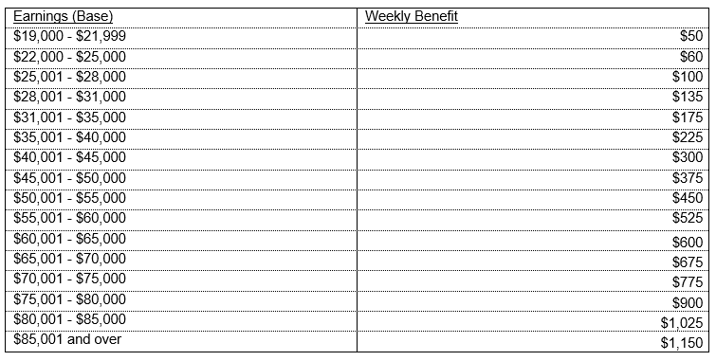
Current Configuration:
We have created 16 plans each plan has the Additional Eligibility Criteria for the salary range for the specific coverage amount offered.
Issue: If an employee’s salary changes during the year it is terming them from the plan and they must be manually enrolled back into the original plan based on SSN.

Options:
- Is it possible to change the system to consider the Update Election for Salary Changes when Gross Annual Salary or Benefit Salary are used in the Additional Eligibility Criteria
  - This will still require a manual update before every enrollment but it will stop the termination issue throughout the year.

- Another possibility to accommodate this plan is the change outlined below. I think this option would be used more if it is possible

In addition to “Start Age Range” and “End Age Range” could we add “Start Salary Range” and “End Salary Range”?

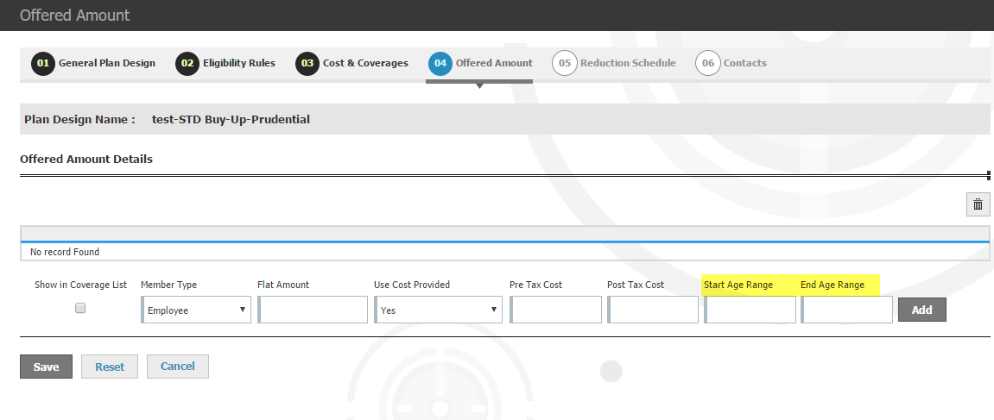

This option would eliminate the need for 16 separate plans. The salary would need to consider both settings below
